A Novel Study

Thumble Tumble and the Cauldron of Undry

By A.H. Proctor

Pupil’s Pack
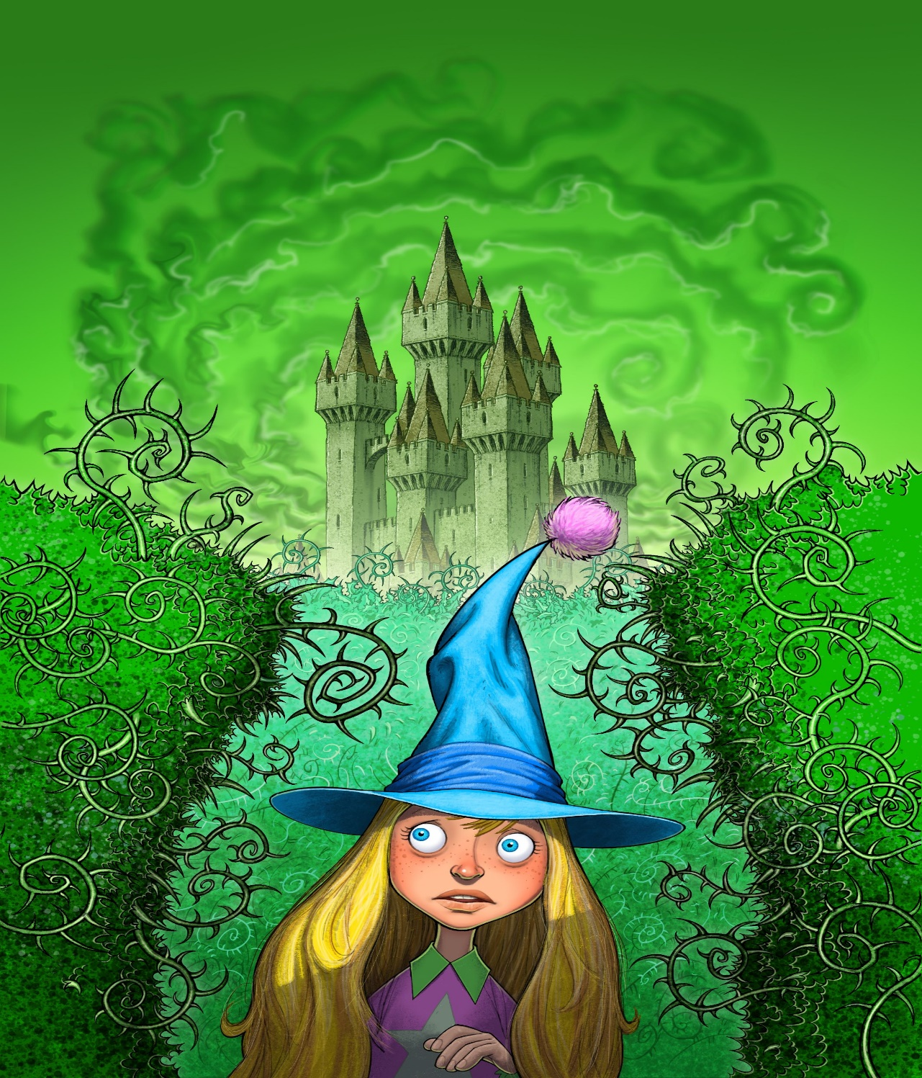

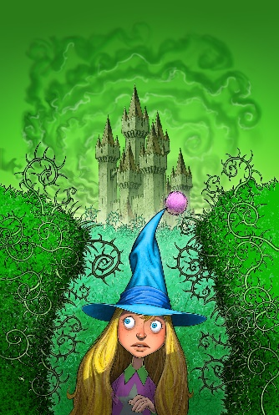

Before Reading – Book Wizard Strategies

Book Wizards ask questions and look for clues before opening the book!

Discuss the following questions with your reading partner:

- Is it a fiction or non-fiction text?
- What can I predict from the title, the picture, the blurb and the author?
- What can I visualise from the title?
- What do I know already about this type of genre?
- Have I read similar texts?
- What do am I looking forward to finding out about the characters/plot/setting?

During Reading – Book Wizard Strategies

During reading Book Wizards:

- Visualise the characters, setting and action

- Ask questions about the text

- Identify themes from the text

- Check for main ideas

- Sometimes make notes or highlight new vocabulary and interesting phrases

- Use decoding strategies to help them read new vocabulary

- Use a variety of strategies to help them to understand the meaning of new words (‘Word Wizard Strategies’ & ’Word Wizard Dictionary’)

- Re-read certain parts to help their understanding of the text

- Look out for important punctuation

After Reading Strategies

After reading Book Wizards:
- Make predictions using clues from the text

- Discuss the text with other Book Wizards - ask and answer questions and make predictions

- Discuss and compare opinions on techniques used by the author to create characters, setting and plot

- Re-read part of the text – highlighting key ideas and discussing their understanding of new vocabulary

- Consider how they might use the author’s techniques and new vocabulary in their own writing

- Summarise the main events and important information

Before Reading:
I can use before reading strategies to make predictions and ask questions

Look closely at the illustration on the cover. Use the thinking routine below to make predictions and ask questions you may have, before reading the text.

I see | I think | I wonder

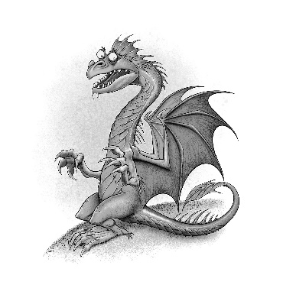

Chapter 1 - And Then There Was One

Learning Intention: I can use evidence from the text to make predictions

Read Chapter 1 thenmake some ‘Magical Predictions’, using evidence from the text!
Magical Predictions!

Prediction | Evidence
Word Wizards!

Learning Intention: I am learning to use a variety of strategies to help me understand the meaning of new vocabulary

Scan the text to find the following words in Chapter 1. Work with your reading partner or trio to define the words. Discuss the strategies which you used for each word. Use your ‘Word Wizard Strategy’ list to help you. (Not all words will have a prefix or suffix)

Word/Phrase | Page No. | Definition | Word Class | Prefix? | Suffix?
Luminous | 5
Appetising | 5
Ignite | 8
HIDEOUS | 9

Add the word in CAPITALS to your ‘Word Wizard Dictionary’.

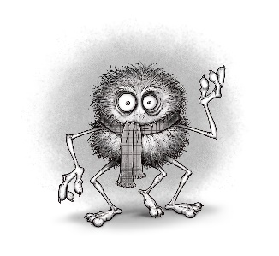Word Wizard Dictionary

Word | Definition | Word Class | Sentence
 |  |  | Prefix | Suffix
Word | Definition | Word Class | Sentence
 |  |  | Prefix | Suffix
Word | Definition | Word Class | Sentence
 |  |  | Prefix | Suffix
Word | Definition | Word Class | Sentence
 |  |  | Prefix | Suffix
Word | Definition | Word Class | Sentence
 |  |  | Prefix | Suffix
Word | Definition | Word Class | Sentence
 |  |  | Prefix | Suffix
Word | Definition | Word Class | Sentence
 |  |  | Prefix | Suffix

Word Wizard Strategies

Strategies to help you become a wonderful Word Wizard!

When I am unsure of the meaning of a word I can:

- Stop and think about what I already know

- Study the word closely – the beginning, the middle & the end to look out for grammar and punctuation clues:

  - Do you know any similar words?
  - Can you make a smart guess about the origin of the word?
  - What class of word is it?
  - Does it start with a capital?
  - How does the word end
  - Does it start with a prefix or end with a suffix.
  - Do you know the meaning of part of the word?

- Leave the word out and read forwards and backwards to the end of the sentence

- Read the sentences before and after the word

- Guess a synonym for the word, does it fit well into the sentence?

- Discuss the word with a partner

- If you are still unsure use a dictionary

Chapter 2 The Three Legged Haggis

LI: I can answer literal, inferential and evaluative questions relating to a fiction text.

- Why did Morven go to McCools’ house if she’d never met him before?
- Why might it have been difficult to find McCools’ house?
- What speech do you think humans said before dining on Haggis?
- Write a definition for Haggis and neaps for visitors to Scotland.
- Had Morven had ever seen a Haggis before she met McCools?
- What did McCools give Morven to make her feel better?
- Describe what Lizzie’s character might have been like. Give reasons for your answer.
- Use three adjectives to describe Morven’s character, using evidence from page 16.

Chapter 2 - Word Wizard Challenge

Work in pairs/trios to locate and discuss the meanings of the words below. Add the word in CAPITALS to your ‘Word Wizard Dictionary.

Word | Page no.
Recluse | 12
Pleaded | 13
Extinction | 14
IMMENSE | 15
Morph | 16

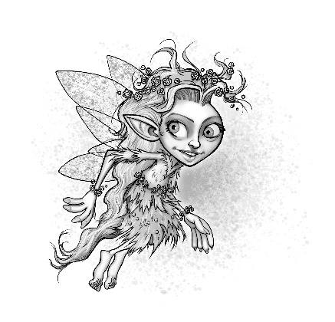

Chapter 3 Breakfast at Devil’s Maze

Characterisation

  - Lily, Boris and Torgle all use a safe, children’s messaging app, called ‘WizAp’. Use evidence from the text to create an online profile for Lily

  - Write 5 posts on ‘WizAp’ to describe the events of chapter 3 from the point of view of one of the characters (Lily, Boris or Torgle)

For example:
Lily -
6.00am
I’m SOOOO excited, it’s my 96th birthday today!!!

Chapter 3 - Word Wizard Challenges

Learning Intention: I am learning to use a variety of strategies to help me understand new vocabulary

1.Word Wizard Challenge - Work in pairs or trios to discuss the definitions of the words below. Add the word in CAPITALS to your ‘Word Wizard Dictionary.

Word/Phrase | Page
PECULIAR | 23
Mischievous | 24
Glistened | 25
Toxic | 26
HYBRID | 27

2.Word Wizard Challenge: Discuss what the idiom below means with your parter/trio.

Boris wasn’t the sharpest tack in the box.

Create an idiom which is the opposite of this.

Chapter 3 to 5 - Reading into Writing

Learning Intention: I can identify and describe techniques and language used by authors to create and develop fictional characters.

Work with your partner/trio to find examples of the following:

Characterisation Technique | Examples from the text
Stereotypical name
Colour
Setting
Alliteration
Adjectives & descriptive phrases
How the characters speak - words used/tone
How the characters’ move/body language/facial expression
Strengths/Weaknesses/Special Powers

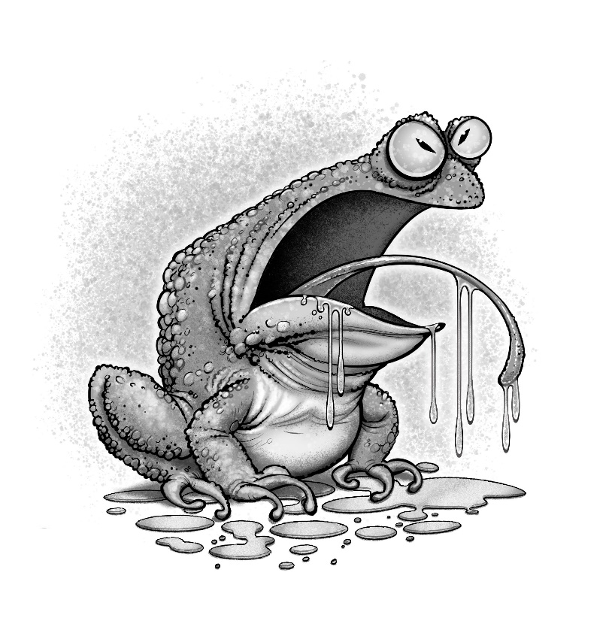

Chapter 3 to 5: Writing & Creating a Character

Learning Intention: I can create fictional characters

You will plan and create a character description of your own Flower Nymph.
Remember to use some of the Wizard words from your dictionary!

Science, Technology, Engineering, Arts, Mathematics:

STEAM Challenge:

CHALLENGE

Create a model of a Flower Nymph which will ‘float’ and ‘spin’! (see page 21)

What problem do I need to solve?

Design the wings so that the model Nymph floats to the ground and avoids ‘splattering into the ground’!

What supplies will I use?

What is my plan?

What worked well?

What would I change to improve the design?

What have I learned from doing this challenge?

Chapter 4 – Loo Roll Confetti

Learning Intention: I am learning to create different types of question

In pairs/trios, create three literal questions, two evaluative and one inferential question relating to Chapter 4.

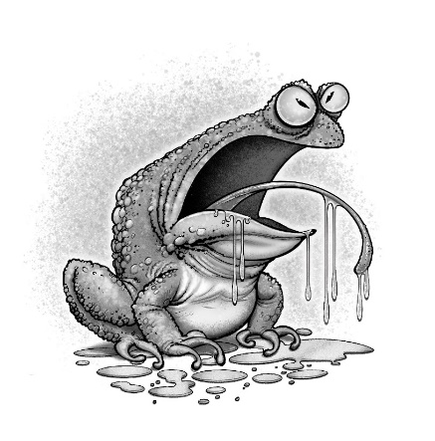

Chapter 4 – Loo Roll Confetti

Learning Intention: I can describe the techniques and language used by an author to create tone and atmosphere

Scan the text and to find examples of how the author uses humour to entertain the reader.

Reading into Writing

Learning Intention: I can identify and describe the features of a recount

Re-read pages 34-36 – discuss the meaning of ‘paparazzi’ and the features of a ‘gossip magazine’.

Writing – You are a Celebrity Reporter!

Learning Intention: I can write a recount

Create a column for your own gossip magazine - recounting the events between Lily, Serena and Torgle, using humour to entertain the reader.

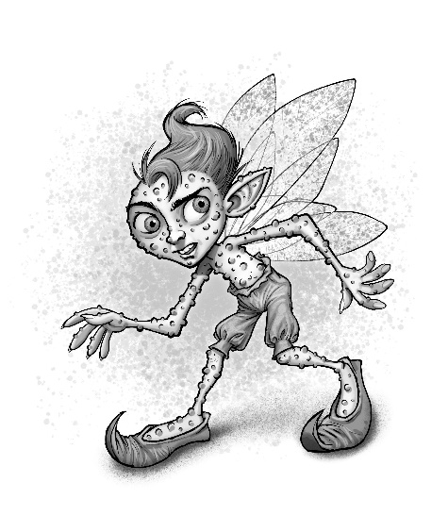

Chapter 5 – The Dark Witches’ Lair

Word Wizard Challenges:

1.Work in trios/pairs to find synonyms from the text for the words in the table below

Word | Synonym
Changed - page 38
Layer - page 39
Lit-up - page 40
Many, several - page 41
Shining, glowing - page 42
Gloopy or thick - page 42
Astonishing, amazing page 43
Slashed, cut - page 46

2. Choose 2 adjectives from the table above to add to your Word Wizard Dictionary.

Chapter 5 - Reading into Writing

Learning Intention - I can identify and describe techniques and language which authors use to create a setting

Think, Pair, Share

Work in pairs/trios - to discuss your favourite setting descriptions from Chapter 5. Why do you like them? What is so good about them? Why are they effective? What techniques has the author used to help you visualise the setting?

Scan the text to find examples of how the author has used the following techniques to create setting in Chapter 5:

Author’s Technique | Examples
Descriptions of colour/light/dark
Descriptions of weather or temperature
Personification
Similes or metaphors
Impressive adjectives or adjective phrases to describe what the characters hear/see/smell/touch or feel/taste.

Chapter 5 - Writing

Learning Intention: I can create an imaginative setting description

Create your own setting description for one of the titles below:

The Enchanted Forest
The Haunted Hospital
The Derelict Boarding School
The Castle
The Abandoned Fairground/Cinema/Mansion
The Ghost Town

(Include at least 3 Wizard words from your dictionary)

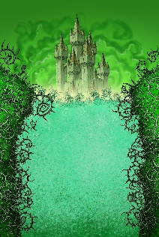

Chapter 6 – Tweezel Berries

Word Wizard Challenge

Learning Intention: I can identify and describe techniques and language used by the author to build tension

1. Find two POWERFUL verbs to add to your Word Wizard Dictionary. Discuss your word selection with your partner/trio

2. Discuss why the author might have used these verbs in Chapter 6

Chapter 7 – Body Pumps

Word Wizard Challenges

1. Find as many synonyms as possible which the author uses instead of ‘said’. Discuss the author’s choice of words, why doesn’t she just use ‘said’?

2. Choose two of the synonyms to add to your Word Wizard Dictionary

3. Scan the text to find interesting adverbs used by the author to describe how the characters speak.

4. Choose two adverbs to add to your Word Wizard Dictionary.

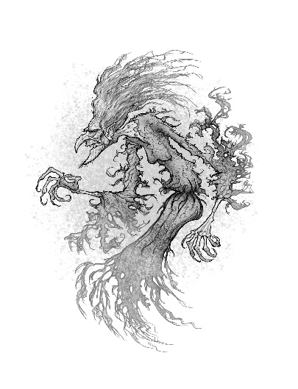

Chapter 8 – Dead Souls Walking

Before Reading chapter 8 - write a brief summary of the story so far - only include key information
.

Chapter 8 – Reading into Writing

Learning Intention: I can identify and describe how authors use setting descriptions to build tension in a text

- Read the setting description in the first two paragraphs on page 65 - discuss how the setting changes. How does this change the atmosphere in the story?
- Discuss why the author might have decided to change the setting description? How does it make the reader feel? How does it help the reader predict what might happen to the character, Buttercup?
- Discuss other texts which you may have read or seen in which a change of setting indicates that something important or frightening is about to happen?
- Discuss the differences in how a change of setting is created in books and in films.

Wizards’ Film Production Challenge

Film Literacy

Learning Intention: I can identify and describe techniques used by film makers to change the tone and atmosphere in a film

Learning Intention: I can create a short film

Watch the clip and discuss the techniques used by the film maker to build tension.

- Skim chapters 6 - 7
2. Work in trios to create a storyboard for the events leading up to the change of setting at the start of Chapter 8.
3. Use the storyboard to create a trailer (using iMovie or Windows Movie Maker) - ending on a cliffhanger.

Chapter 8 - READING

Learning Intention: I can answer different types of questions relating to a text

Before writing your answers, discuss which of the questions are literal, evaluative and inferential.
- Do you think that Buttercup really saw a boy’s face on the wall? Give Reasons.
- Why had Buttercup not believe in these creatures before?
- Do you think Buttercup really didn’t believe the stories when she was young? Give reasons.
- What was different about the third witch?
- What type of creatures are Mantigh?
- Why did Mogdred despise Silusa?
- How would Silusa have felt about how Mogdred had treated her after her mother died?.
- Why did Mogdred want the Cauldron of Undry?
- Find evidence from Chapter 8 which shows that Mogdred is a very clever and cunning character?
- Why did Silusa decide not to find and kill Buttercup at the end?
- How do you think Buttercup is feeling at the end?
- How do you think Buttercup will be feeling about Blade?

Chapter 8 - Storytelling Challenge

Learning Intention:

- I can plan and create a traditional tale
- I am learning to vary my pace, gesture, tone and expression to engage an audience

1. In pairs/trios discuss your favourite fairy-tales or stories from Scottish folklore.

2. Discuss how the stories are often used to give a message or teach a lesson to children.

3. Discuss the structure of traditional stories

4. Listen to the teacher telling a traditional Scottish tale.

5. In pairs/trios create your own fairy-tale – this will be planned and created verbally.

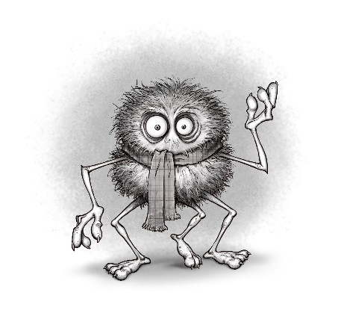

Chapter 9 – Number 1 Goatfell

Word Wizard Challenge

Use the clues to complete the crossword.

Hastily- Adverb to describe how someone moves or talks in a quick manner pg75
Massive - Adjective to describe something or someone that’s is huge. pg 76
Devastation - Noun. A scene of complete destruction pg 78
Defeat - Verb. To win against or conquer an opponent in sport or battle pg81
Descended - Verb (past tense). To go down. Synonym, lowered.pg82
Tome - Noun. A very large book. pg 81
Illusion - Noun. An pg 85

Chapter 9 - Question Challenge

Learning Intention: I am learning to create different types of questions about a text

With your partner/trio create three literal questions, two personal and one inferential question for another reading pair/trio to answer.

Coding Challenge

Your challenge is to design and market a game involving some of the characters from the novel.
Planning page - age group, aim of the game, friends and enemies, special powers, gadgets, how the scoring system works, bonus points.

Name of the game
Aim
Characters
Special Powers
Gadgets
Explain how the scoring system works

- Trial the game
- Improve and create the final version
- Create a promotional advert for the game
- Post on the Thumble Tumble Twitter page

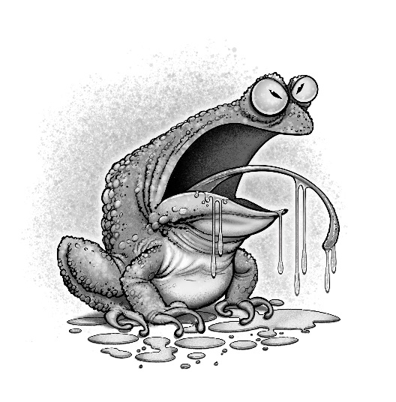

Chapter 10 – The Watcher

Word Wizard Challenges
- Scan the text for 2 interesting words to add to your Word Wizard Dictionary.
- Check your definition using a dictionary.
- Discuss the words with your partner or trio.
- Challenge your partner to use at least one of the words you have added to your dictionary in their written or oral work this week. They will earn a point for each correct use of the word.

Keep score using the Word Wizard Score Card and add up the points at the end of the week. F points will be awarded for each appropriate use of the word.

Who will be the Word Wizard Champion???

Word Wizard Score Card
Word | Evidence of using the word | Points
e.g.Hideous | Used in my homework sentence; The hideous creature disappeared in a puff of smoke. | 5
 |  | ________

Final Score:____points

Health and Well-being – Is Torgle Being Bullied?

LI: I understand that there are people I and others can talk to, and ways to get support when experiencing bullying

- With your partner/trio discuss how Torgle is feeling at the beginning, middle and end of Chapter 10. Record your descriptions of his feelings using the character portrait below

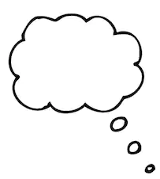

- How do you feel about Torgle at the end of Chapter 10?

- Torgle is feeling bullied and threatened by Serena. He has sent you a message, looking for advice. Imagine Torgle is your friend and write a reply, giving him advice on how he can get help

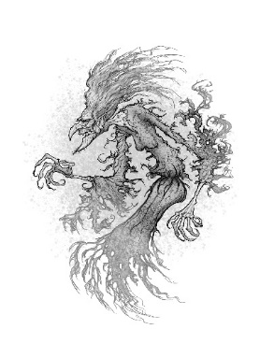

Chapter 11 - The Sleeping Gardner

Reading into Writing

Learning Intention: I can identify and describe the features and structure of an imaginative text

After reading Chapter 11 add the key details of the story about ‘The Sleeping Gardner’ to a Story Mountain Template.

Writing Challenge – Spooky Stories!

Learning Intention: I can plan and create an imaginative text.

Choose a character from the list below or come up with one of your own, then use the Story Mountain template to help plan your own spooky story involving your chosen character and the Mantigh.

Character suggestions: a nosey neighbour, a schoolchild who has wandered away from his class during a school trip to the island, a history vlogger who wanted to find out about the mysterious Brodick Castle, a ‘ghost hunter’ who wanted to make a T.V. show about the mystery of the Mantigh, a supermarket delivery person who was given the wrong address and arrived at Brodick Castle , after sunset by mistake.

After writing and editing your text, share your stories with the author on twitter @ah_proctor. If she’s impressed she might award the author of the best story with a bar of ‘Scoffolicious Chocolate’, handmade by Isla, one of the Good Witches, on the Isle of Arran.

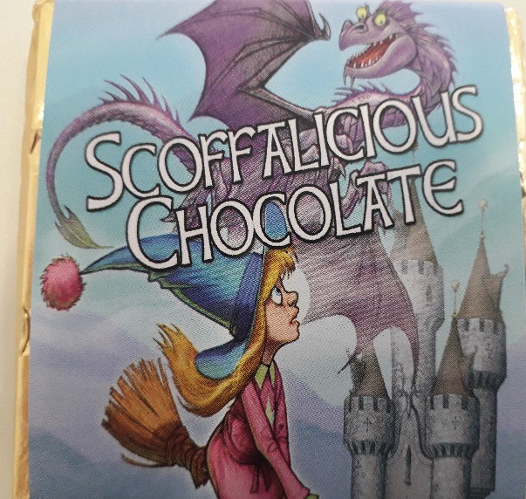

Chapter 12 – Book Shower

Health and Well-being – Why do some people bully others?

- Discuss the reasons why some people become bullies.

- Discuss the similarities between Serena’s treatment of Torgle and Mogdred’s treatment of Serena.

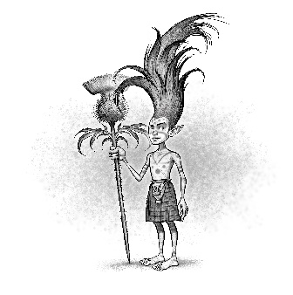

Chapter 13 – Attack of the Thistle Pixies

True, False, Justify

Learning Intention: I can use evidence to justify my opinions about a fiction text

Tick the statements below as being True or False. Justify your answers to your partner/trio by using evidence from the text. You might not always agree but that’s ok as long as you can justify your opinion or answer.

Statement | True | False
McCools traveled to the Holy Isle in his magic elevator.
Kyle was a mischievous Thistle Pixie.
Jock’s enormous body was always a disadvantage.
The Thistle Pixies chose tartan kilts to make them stand out in a crowd.
Jock was a very caring and considerate dragon.
McCools was very knowledgable.
The author used stereotype when creating the Witch Trolls characters, Gorgour and Lumpsila.
Thumble Tumble’s ability to successfully cast spells is improving.
Thumble Tumble is jealous when Jock is praised by McCools.
McCools really dislikes Thumble Tumble.

Character Art Challenge

  - Re-read the descriptions of the two Witch Trolls and use the description to draw a portrait of them. Only show your picture to your partner/trio when you have both/all finished. Discuss similarities and differences.

  - Create a brief description of your own Thistle Clan leader. Then swap it with a partner and draw the image, using their description.

Chapter 14 – Groucho’s Gauntlet

Learning Intention: I can use my understanding of a text to answer questions and complete tasks after reading
- What type of literary technique has the author used in the title of Chapter 14?
- Use this technique to create a title for a chapter about Lumpsila and Gorgour.
- Scan the text to find evidence to show that Jock is very protective of Thumble Tumble.
- Do you think Groucho’s name suits his character? Give reasons.
- Why might Thumble Tumble not remember having met Groucho before?
- Is Thumble Tumble a considerate girl? Give Reasons for your answer.
- Why had Groucho made Thumble Tumble run through the gauntlet?
- What simile was used to describe Hibert?
- Create a simile to describe Groucho’s thin appearance.
- Why do you think Groucho won’t tell Thumble Tumble about why her mother died?

Word Wizard Challenge

  - Scan the text to find synonyms for the following words:

Words | Page number | Synonym
Sick | 115
Exploded | 118
Danger | 122
Injured | 122

  - Scan page 120 for the word fastidious, write your own definition and state what class of word you think it is. Use a dictionary to check your answer and add it to your Word Wizard Dictionary.

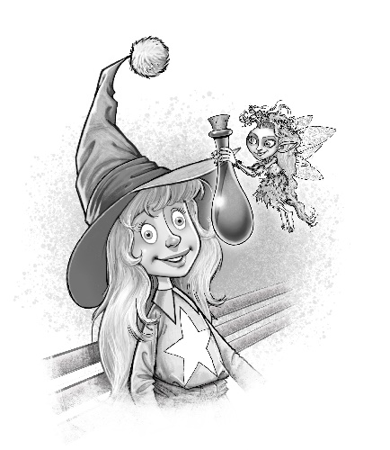
Chapter 16 – Fairy Dew

Predictions

Learning Intention: I can make predictions as I read

- McCool’s said, ‘But now that Mogdred knows who she is, perhaps it’s time to stop hiding the truth from her and start training her?’ What is the secret that Isla and the other characters, are hiding from Thumble Tumble? What type of ‘training’ is McCool referring to?

- Why do you think Mogdred would want to kill Thumble Tumble?

Themes

Learning Intention: I am learning to identify and discuss a writer’s theme

Re-read page 132 starting from, ‘Poor Silusa,’ said Thumble Tumble sadly.

Discuss the theme or themes which arise from this paragraph.
Discuss how these themes have come up several times, throughout the novel.

- Give examples of how some characters have shown good and bad sides to their personality.
- Give examples of characters who have been influenced by the evil actions of others.
- Give examples of characters who seem to be purely evil and those which are purely good.
- Give examples of characters who are taking action to make sure that evil does not destroy the lives of others.
- Discuss why you think the author chose to include the good v evil theme? What message do you think the author is trying to get across to the reader?
- Give real life examples of people you know or people you’ve learned about in school or from the media who have used positive actions to stand up for what is right and to make the world a better place for everyone.

Reading into Writing

Learning Intention: I can identify and describe the structure and features of a biographical report

Study the following extract about Martin Luther King. Identify the features of a biographical report.
___________________________________________________________
- Occupation: Civil Rights Leader
- Born: January 15, 1929 in Atlanta, GA
- Died: April 4, 1968 in Memphis, TN
- Best known for: Advancing the Civil Rights Movement and his "I Have a Dream" speech
Biography:
Martin Luther King, Jr. was a civil rights activist in the 1950s and 1960s. He led non-violent protests to fight for the rights of all people including African Americans. He hoped that America and the world could become a colorblind society where race would not impact a person's civil rights. He is considered one of the great orators of modern times, and his speeches still inspire many to this day.

Where did Martin grow up?
Martin Luther King, Jr. was born in Atlanta, GA on January 15, 1929. He went to Booker T. Washington High School. He was so smart that he skipped two grades in high school. He started his college education at Morehouse College at the young age of fifteen. After getting his degree in sociology from Morehouse, Martin got a divinity degree from Crozer Seminary and then got his doctor's degree in theology from Boston University.
Martin's dad was a preacher which inspired Martin to pursue the ministry. He had a younger brother and an older sister. In 1953 he married Coretta Scott. Later, they would have four children including Yolanda, Martin, Dexter, and Bernice.

How did he get involved in civil rights?
In his first major civil rights action, Martin Luther King, Jr. led the Montgomery Bus Boycott. This started when Rosa Parks refused to give up her seat on a bus to a white man. She was arrested and spent the night in jail. As a result, Martin helped to organize a boycott of the public transportation system in Montgomery. The boycott lasted for over a year. It was very tense at times. Martin was arrested and his house was bombed. In the end, however, Martin prevailed and segregation on the Montgomery buses came to an end.
When did King give his famous "I Have a Dream" speech?
In 1963, Martin Luther King, Jr. helped to organize the famous "March on Washington". Over 250,000 people attended this march in an effort to show the importance of civil rights legislation. Some of the issues the march hoped to accomplish included an end to segregation in public schools, protection from police abuse, and to get laws passed that would prevent discrimination in employment.
It was at this march where Martin gave his "I Have a Dream" speech. This speech has become one of the most famous speeches in history. The March on Washington was a great success. The Civil Rights Act was passed a year later in 1964.
How did he die?
Martin Luther King, Jr. was assassinated on April 4, 1968 in Memphis, TN. While standing on the balcony of his hotel, he was shot by James Earl Ray.

Writing – Biographical Report

Learning Intention: I can plan and create a biographical report

Write a report on a person whom you admire because they have stood up for the rights of others and made a positive contribution to the world.

  - Use what you know about the features of a biographical report to create success criteria.
  - Carry out research and make notes
  - Use your notes to plan and write the report
  - Remember to include your sources

Chapter 17 – Assault on Brodick

Word Wizard Challenge

Scan the text to find synonyms for the words below
Word | Page number | Synonym
Still | 134
Spooky | 134
Painful | 134
Disappeared | 137

Summary

Provide a brief summary of the first part of the battle, only including the most important details from the chapter.

Chapter 18 – Bridge ‘Club’
Discuss how the author, once again, focuses the reader’s attention on the themes of good and evil in the story.

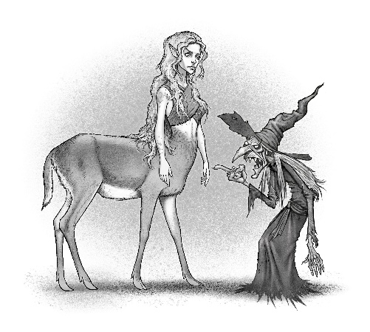

Chapter 19 – Mogdred’s Vow

Learning Intention: I can use evidence from the text to answer questions and complete tasks after reading

- Read the first four lines of page 146. Why do you think the author chose to start the final paragraph with such a dramatic setting description?
- What clues has the author given which show that the story is to be continued?
- What questions would you like to find out the answers to from the third novel?
- Make 3 predictions about the sequel to this novel. Write them down, before reading the third book in the Thumble Tumble series, ‘Thumble Tumble and the Eagalach Cup’.

Book Club Challenge

Join up with another pair or trio to create a book club vlog about ‘Thumble Tumble and the Cauldron of Undry’.

Before filming, plan a list of topics or questions you would like to discuss with your book club.

After planning, work together to decide on a final list, each book club member can ask two questions or raise two points for discussion. All members of the group will have the opportunity to contribute their opinions.

Tweet the Author
- With your partner/ trio discuss questions would you like to ask the author or what advice about imaginative writing you would like from her?

- Share these with your class and then decide on the top 5 questions you would like to ask in a Tweet to @ah_proctor

Wizards’ Film Production - Storyboard

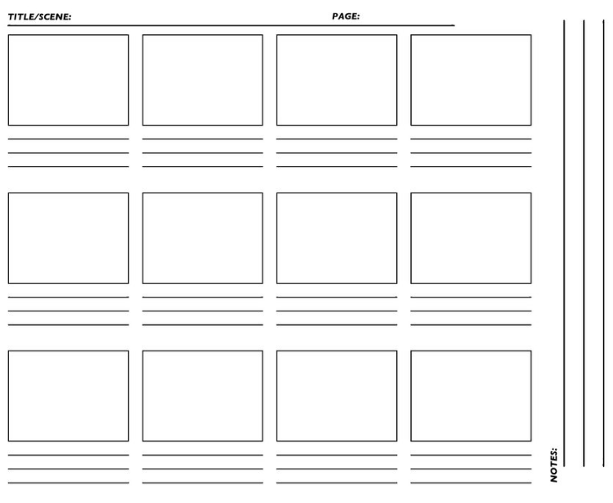
WizAp

Wizard Avatar

Online Wizard Nickname :_____________________

Best Friends:

Special Powers:

Likes and Dislikes:

Messages:

